24.2.21
T: Can I explain the three states of matter?
Solid | Liquid | Gas
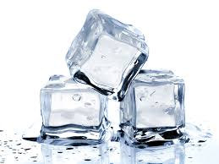  hard, firm, cold, wet, frozen, clear, transparent | 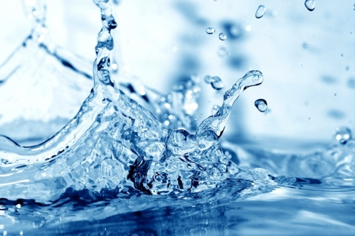  wet, warm, cold, hot, clear, transparent, still, wavy | 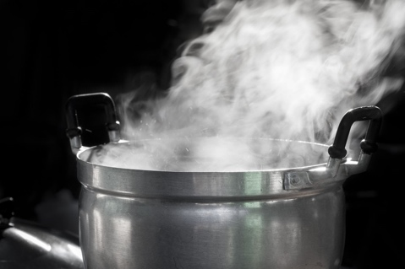  Wet, cloudy, hot, warm, thick, white

Use your word bank to complete your sentences.
Try to use three adjectives:

Water in the form of a sold is__________________________________________.

Water in the form of a liquid is _________________________________________.

Water in the form of a gas is __________________________________________.

When water freezes, it becomes a ____________.

When water evaporates, it becomes a ___________.

When ice melts, it becomes a _____________.

